Chelmsford & Mid Essex CAMRA  Essex Pub of the Year 2025 (POTY) | 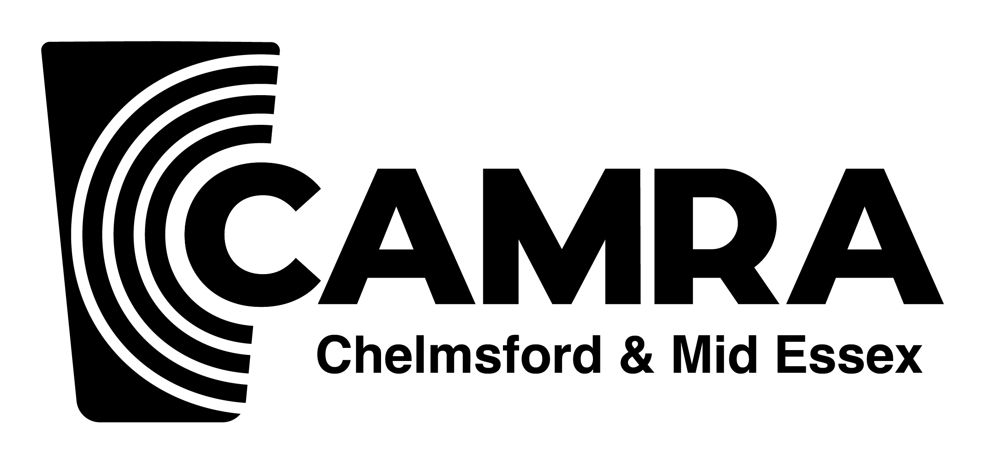

The judging for the Essex Pub of the Year 2025 is now open. The following pubs have won their branch round of voting and are:

- Ale House, Colchester
- Hurdlemakers Arms, Woodham Mortimer
- Railway Arms, Saffron Walden
- Mile & a Third, Westcliff
- New Bell Inn, Harwich,
- Rising Sun, Stanford Lee Hope
- Endeavour, Springfield

Voting can be using an on-line form. You can fill it in one pub at a time and click the “Save and Continue later” button.

More information:
The POTY voting Guidance can be found a here
The POTY Judging Form is here
Please remember that you have to judge all pubs - see new rule below* - for your scores to count. Please be fair and impartial.
The branch will not be running a mini bus this year for the Essex judging.

The deadline is end of Sunday 18 May 2025

*New rule for 2025
The East Anglian Regional management team has decided that you do not judge your own branch’s POTY. This reduces the number to be judged to 6. You are welcome to enter scores for your branch's POTY, but they will be excluded from the overall scores.

